CREATE A FORM

|  |  |
| --- | --- |
| Date | 06 NOV 202 |
| Team ID | PNT2022TMID07561 |
| Project name | Personal assistance for senior who are self- reliant |

Connecting nodes using node-red:

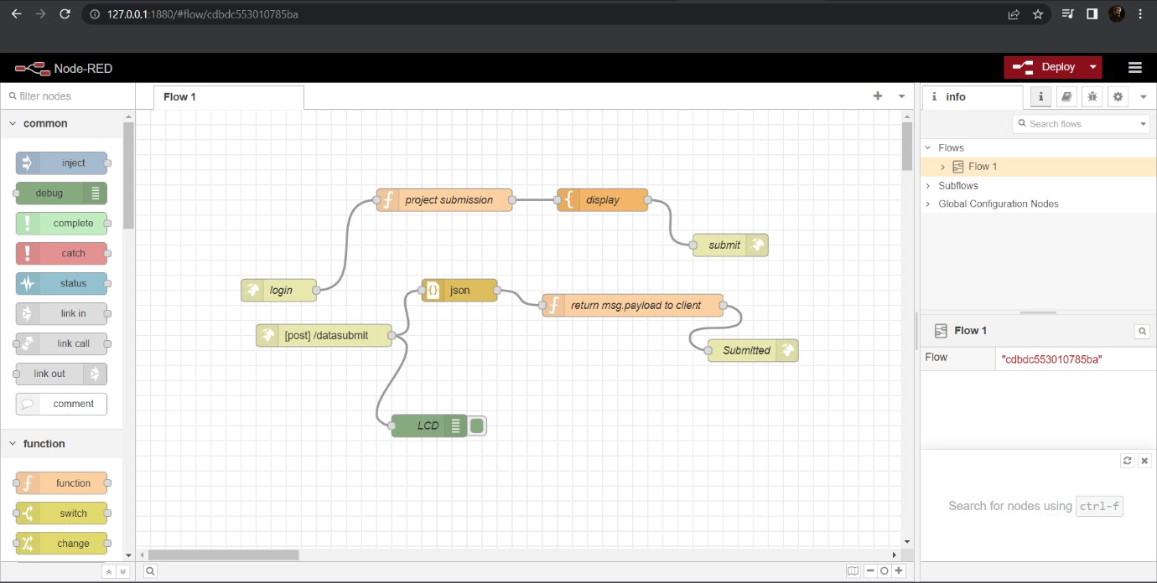

After deploying the nodes:

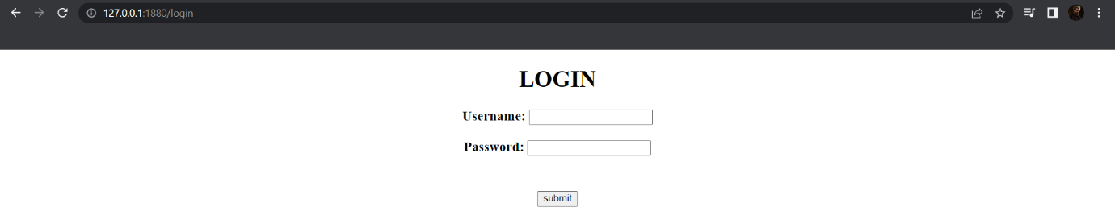

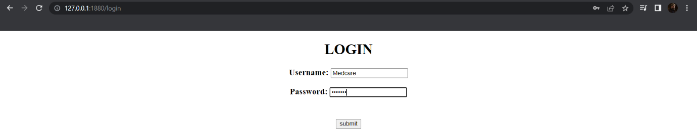

After clicking on Submit button:

